12.71: a) The stars are separated by the diameter of the circle d =2R, so the gravitational force is 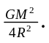

b) The gravitational force found in part (b) is related to the radial acceleration by 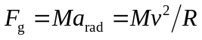 for each star, and substituting the expression for the force from part (a) and solving for v gives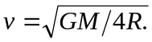The period is 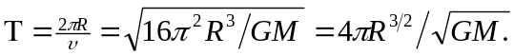 c) The initial gravitational potential energy is 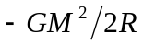 and the initial kinetic energy is 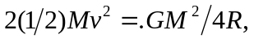 so the total mechanical energy is 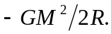If the stars have zero speed when they are very far apart, the energy needed to separate them is 